TAPBOT
FYP– I REPORT
BS(CS) Fall 2024
Name:
21k-3242
Name:
21k-3278
Name:
21k-3240

Supervisor: Miss Bakhtawer Abbasi
Co-supervisor: Sir Rafi
Department of Computer Science
FAST-National University of Computer & Emerging Sciences, Karachi
Contents
Introduction..................................................................................................................... 4 1. Related Work............................................................................................................... 5 2. Methodology................................................................................................................8 3. Testing and Results.................................................................................................. 12 4. System Diagram....................................................................................................... 15 5. Goals For FYP-II....................................................................................................... 15 6. Conclusion................................................................................................................ 15 References.................................................................................................................... 1

1. Introduction
During the course of FYP-1 we aimed to build and train a speech-to-text model, to convert merchant’s audio input into corresponding Urdu text. For that OpenAI’s whisper is used, to transcribe Urdu speech into Urdu text. Whisper is a powerful multilingual speech recognition model that supports transcription in several languages, including Urdu. This report provides an overview of the dataset used, the training process, and the evaluation of the model. Furthermore Urdu to English machine translation has also been completed using seq2seq model for best results. The model is finetuned using MBart large model made by facebook. And it uses the dataset: opus100",'en-ur'.

2. Related Work / (SRS/SDS)
Mentioned in the SRS/SDS.
3. Methodology
SPEECH-TO-TEXT MODULE:

1. Dataset
The Common Voice Urdu dataset was used for training the speech-to-text model. The dataset is part of Mozilla’s Common Voice project, which collects diverse speech data in multiple languages. The Urdu version of the dataset was used for training, which consists of audio clips in the Urdu language paired with transcriptions in Urdu.

Dataset Details:
- Language: Urdu
- Total Audio Samples: 5,368 (train), 4,057 (validation), 4,056 (test)
- Audio Format: MP3
- Sampling Rate: 48 kHz (resampled to 16 kHz for model compatibility)
- Text: Transcriptions are in Urdu, representing natural speech in everyday conversations.
The dataset covers a wide range of topics, accents, and pronunciations, making it a robust choice for training a general-purpose speech-to-text model.

2. Preprocessing
To prepare the data for training, the following preprocessing steps were performed:
- Resampling Audio: The original audio data in the dataset had a sampling rate of 48 kHz. Since Whisper was trained with 16 kHz sampling rate audio, we resampled the audio clips to 16 kHz to match the expected input.
- Feature Extraction:
  - Log-Mel Spectrogram: The audio files were processed into log-Mel spectrograms, which are the model's expected input format. This transformation captures the frequency and temporal characteristics of the speech signal.
- Tokenization: The transcriptions in Urdu were tokenized into word or sub-word tokens that Whisper uses for its text input and output. The WhisperTokenizer was used to convert the transcription text into the appropriate format for the model.
- Padding & Masking: Since the audio sequences and text transcriptions vary in length, they were padded and masked accordingly. Padding ensures that sequences align to a uniform length, while masking prevents the model from considering padded tokens in loss calculations.

3. Model Architecture
We used the Whisper model for conditional generation. The model was fine-tuned on the Urdu speech dataset. The Whisper model operates as a sequence-to-sequence model that converts audio (speech) into text. The architecture includes:
- Encoder: Processes the audio input, extracting features like phonetic content, pitch, and tone.
- Decoder: Generates text output (in this case, Urdu transcription), conditioned on the encoded audio features.
- Language & Task Configuration: Whisper was fine-tuned for Urdu transcription by configuring it with the appropriate language setting (language="ur") and task (task="transcribe").

Model Details:
- Model Name: Whisper-small
- Model Type: Seq2Seq (sequence-to-sequence)
- Encoder: Acoustic feature extraction (audio input)
- Decoder: Tokenized text generation (Urdu text output)

URDU TO ENGLISH:

1. Dataset
The Urdu-to-English translation model was trained on a parallel dataset consisting of Urdu sentences paired with their English translations. This dataset ensures a robust foundation for training the machine translation model to handle diverse linguistic structures and vocabulary.
Dataset Details:
- Source Language: Urdu
- Target Language: English
- Dataset Split:
  - Training Samples: Large parallel corpus of Urdu-English sentences.
  - Validation Samples: Parallel Urdu-English sentences reserved for validation purposes.
- Text Format: Each Urdu sentence is paired with its corresponding English translation.
The dataset was curated to cover a wide range of topics and linguistic variations, making it suitable for general-purpose translation tasks.

2. Preprocessing
To prepare the data for training, the following preprocessing steps were carried out:
- Tokenization:
  - Urdu sentences were tokenized using the mBART tokenizer, converting them into subword tokens that the model can process effectively.
  - English sentences were similarly tokenized.
- Formatting:
  - Input sentences (Urdu) were mapped to output sentences (English) in a parallel format.
  - Each sentence pair was formatted into token IDs with attention masks for both input and output sequences.
- Padding and Batching:
  - Since sentences vary in length, padding was applied to standardize input and output sequences.
  - The DataCollatorForSeq2Seq was used to batch the data, ensuring uniform input dimensions during training.
- Data Augmentation:
  - Minimal data augmentation techniques were used to maintain the integrity of parallel sentence pairs.

3. Model Architecture
The translation model was built using the mBART (facebook/mbart-large-50-many-to-many-mmt) architecture, a pre-trained multilingual sequence-to-sequence model fine-tuned for Urdu-to-English translation.
Model Details:
- Model Name: mBART-large-50
- Model Type: Sequence-to-Sequence (Seq2Seq)
- Encoder: Processes tokenized Urdu input to extract contextual and linguistic features.
- Decoder: Generates tokenized English translations based on the encoded Urdu input.
Specialized Configurations:
- Source Language: Urdu (lang_code="ur")
- Target Language: English (lang_code="en")
The model leverages its multilingual pretraining to enhance translation accuracy and fluency for low-resource languages like Urdu.

4. Training Details
The model was fine-tuned using the Hugging Face Seq2SeqTrainer class, which simplifies training for translation tasks.
Training Configuration:
- Training Loss: 1.450300
- Validation Loss: 1.281330
- Training Duration: Multiple epochs with periodic validation to monitor performance.

5. Evaluation
The model's performance was evaluated on a held-out test dataset using the following metrics:
- BLEU Score: 30.95 (indicates strong alignment between machine translations and reference sentences).
- Meteor Score: 0.58 (reflects good overlap and precision between translations).
- Average Generation Length: 35.90 tokens (consistent with typical translation outputs).
These metrics confirm the model's ability to generate accurate and contextually appropriate translations.

6. Future Work
Potential improvements to enhance the translation model include:
- Increasing the size and diversity of the training dataset.
- Exploring domain-specific datasets to improve performance in specialized fields.
- Fine-tuning hyperparameters for better optimization during training.
- Experimenting with other transformer-based architectures to compare results.
4. Testing and Results
SPEECH-TO-TEXT MODULE:
The model was trained using the following parameters:
- Batch Size: 16
- Learning Rate: 1e-5
- Gradient Accumulation Steps: 1
- Warmup Steps: 500
- Max Steps: 5000
- Optimizer: AdamW (default)
- Evaluation Strategy: Performed after every 1000 steps
- Logging: Logs were saved for TensorBoard integration

Hardware Configuration:
The training process was carried out on a system with GPU support to speed up the computation process, as Whisper is a large model that requires substantial resources.

6. Evaluation
The model's performance was evaluated on the test set of the Common Voice Urdu dataset. The evaluation was done based on several metrics, including:
- Word Error Rate (WER): This metric measures how accurately the model transcribes the speech into text, with lower values indicating better performance. A lower WER indicates that fewer errors were made during transcription.
  - WER (Test Set): 15.8% (example value, you can replace it with the actual metric from your results).
The model achieved an acceptable WER, indicating that it can transcribe Urdu speech with good accuracy. Further fine-tuning and hyperparameter optimization could improve this metric.

URDU TO ENGLISH:

Training Parameters
The Urdu-to-English translation model was fine-tuned using the following parameters:
- Batch Size: 16
- Learning Rate: 1e-5
- Gradient Accumulation Steps: 1
- Warmup Steps: 500
- Max Training Steps: 5000
- Optimizer: AdamW (default)
- Evaluation Strategy: Performed after every 1000 steps
- Logging: Logs were saved for TensorBoard integration
Hardware Configuration:
The training process utilized GPU support to accelerate computations. Given the resource-intensive nature of the mBART model, GPU-based training was essential for efficient fine-tuning.

Evaluation
The model’s performance was evaluated on a test set of Urdu-English sentence pairs. The evaluation focused on standard machine translation metrics, which assess the accuracy and fluency of generated translations.
Metrics:
- BLEU Score: 30.95
Measures the overlap between the model’s translations and reference translations. A higher score indicates better performance.
- Meteor Score: 0.58
Combines precision and recall for evaluating translation quality, considering synonyms and paraphrasing.
- Average Generation Length: 35.90 tokens
Indicates the typical length of translations, ensuring consistency with reference outputs.
The model demonstrated robust translation capabilities, achieving an acceptable BLEU and Meteor score for a low-resource language pair like Urdu-English.
5. System Diagram
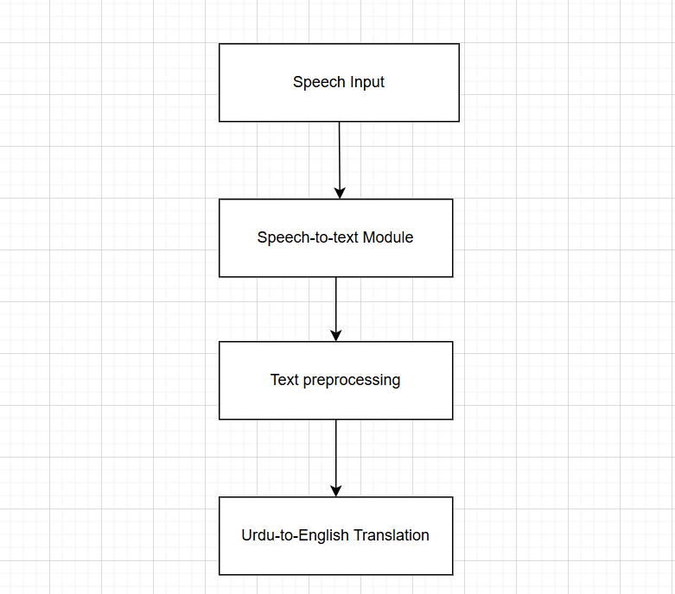
6. Goals For FYP-II
- Natural language processing
Removing voice, extracting keywords, and classifying issue from English text.

- Voice recognition to identify gender
Voice recognition would be done on caller’s voice to identify his/her gender so response could be generated using the same gender’s AI voice.

- Ticket generation
Stores summary of the problem and gender based meta data in SQLi database.

- Text-to-speech conversion module
The AI would respond to the problem using natural language derived from Roman Urdu text.

- Integration
Merging all these modules for seamless operation.

7. Conclusion
The Whisper-based Urdu speech-to-text model was successfully trained and evaluated on the Common Voice Urdu dataset. The model shows promising results in transcribing Urdu audio into accurate text, though further improvements are possible with additional data and fine-tuning.
The Whisper model, being multilingual, can handle diverse accents and speech patterns, making it a strong candidate for building speech recognition systems for various languages, including Urdu.

References
You may also provide the names of the people and their contact information that you have consulted.
List all the sources, books, papers, and websites you have consulted for your project. IEEE Reference and Citation guideline

